**2023 Tournament Results:**

**Results of Men’s Senior City Championship (2 rounds):**

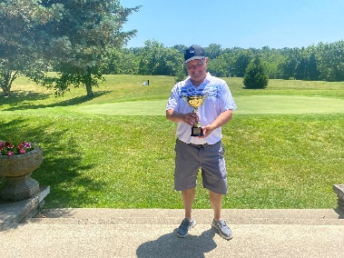1st Place – JT Bellush (147)

2nd Place – Craig Reiner (148)

3rd – Kim Henderson (153)

**Results of Ladies City Championship (2 rounds):**

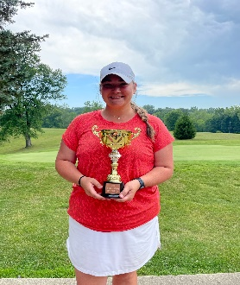1st Place – Kori Johnston (145)

2nd Place – Brooklyn Cromwell (155)

3rd Place – Chloe Mcfaddin (167)

**Results of Girls City Championship (2 rounds):**

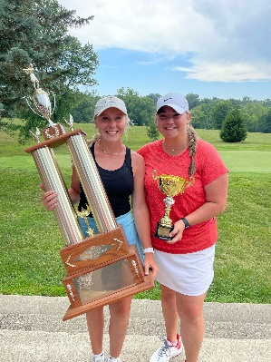1st Place – Chloe McFaddin (167)

2nd Place – Darian Lafferty (171)

3rd Place – Ellie Horton (176)

**Results of Boys City Championship (2 rounds):**

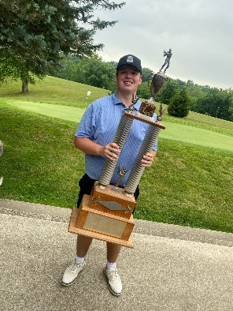1st Place – Jett Jones (160)

2nd Place – Colten Staggs (161)

3rd Place – Evan Tillett (162)

**Results of Mens City Championship (4 rounds):**

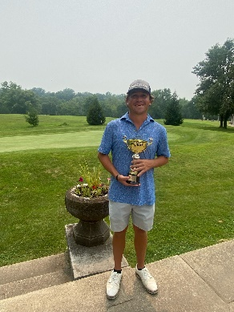1st Place – Korey Smith (279)

2nd Place – Aaron Harrell (283)

3rd Place – Ethan Stanley (285)

**Girls Sectional Event September 16th:**

SECTIONAL CHAMPS

The Lady Stars secured their 11th straight sectional win with a 328 today at Otis Park.

Kenley Craig - 77(PR)

Kinleigh Root - 79

Chloe McFaddin - 80

Ellie Horton - 92

Sammie Nusbaum - 96